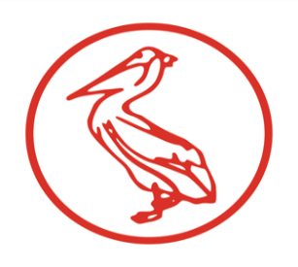
Northern Ireland Blood Transfusion Service

Declaration and Register of Interests of Board Members 2026

NAME | POSITION HELD | 1  Directorships held in Private Companies or Public Limited Companies (PLCs) | 2  Private Companies, Businesses or Consultancies which may own or part own and which may seek to do business with NIBTS | 3  Position of authority held in Charities or voluntary bodies in the field of HSC | 4  Connections with any voluntary or other bodies contracting for NIBTS | 5  Any other interest which you consider are relevant or material
Mr Brendan Garland | Chair | None | None | None | None | Non Executive Member Pharmaceutical Society Northern Ireland  Non Legal Panel Member Industrial and Fair Employment Tribunal
Mrs Karin Jackson | Chief Executive | None | None | None | None | None
Mr Michael Graham | Non-Executive Board Member | None | None | None | None | None
Ms Bernie Lunney | Non-Executive Board Member | None | None | None | None | None
Mr Noel Brady | Non-Executive Board Member | Owner/Founder Consult Nb1 Ltd  Chairman – Continu Ltd | None | Council Member Ulster University | None | Chairman – CITBNI

